* **Objectives:** The objective of this lab is

1. Understand the concept of binary addition and subtraction.
2. Learn about half and full binary adders.
3. Perform binary addition and subtraction using IC74283.
4. Understand the concept of BCD addition and implement a BCD adder using IC74283

* **Equipments:**

1. Trainer board
2. 1 x IC 74283 4-bit binary adder
3. 1 x IC 7486 quadruple 2-Input XOR gates
4. Wires

* **Theory:**

Digital computers perform a variety of information-processing tasks. Among the functions encountered are the various arithmetic operations. The operation of adding two binary numbers is one of the fundamental tasks performed by a digital computer. The four basic addition operations are **0 + 0 = 0**, **1 + 0 = 1**, **0 + 1 = 1** and **1 + 1 = 10**. In the first three operations, each binary addition gives sum as one bit. But the fourth addition operation gives a sum that consists of two binary digits. In such result of the addition, lower significant bit is called as the sum bit, whereas the higher significant bit is called as the carry bit. The logic circuits which are designed to perform the addition of two binary numbers are called as binary adder circuits. There are two types of adder:

**Half adder:** A logic circuit block used for adding two one bit numbers or simply two bits is called as a half adder circuit. This circuit has two inputs which accept the two bits and two outputs, with one producing sum output and other produce carry output.

**B**

**A**

**Sum**

**Cout**

**HALF-ADDER**

**Block diagram of Half-adder**

|  |  |  |  |
| --- | --- | --- | --- |
| **A** | **B** | **Carry** | **Sum** |
| **0** | **0** | **0** | **0** |
| **0** | **1** | **0** | **1** |
| **1** | **0** | **0** | **1** |
| **1** | **1** | **1** | **0** |

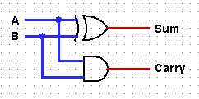

**Fig: Half Adder Truth Table**

**Full Adder:** Full adder can be formed by combining two half adders and an OR gate as shown in above where output and carry-in of the first adder becomes the input to the second half adder that produce the total sum output. The total carry out is produced by ORing the two half adder carry outs as shown in figure. The full adder block diagram and truth table is shown below.

**Full-Adder**

**A**

**Sum**

**B**

**Cout**

**Cin**

**Block diagram of Full-Adder**

**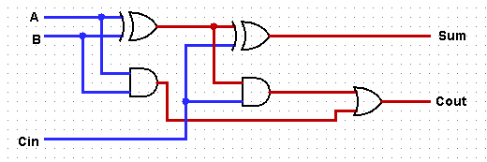  
Fig: Full-Adder**

|  |  |  |  |  |  |  |
| --- | --- | --- | --- | --- | --- | --- |
| **A** | **B** | | **Cin** | | **Cout** | **Sum** |
| **0** | **0** | | **0** | | **0** | **0** |
| **0** | **0** | | **1** | | **0** | **1** |
| **0** | **1** | | **0** | | **0** | **1** |
| **0** | | **1** | **1** | | **1** | **0** |
| **1** | | **0** | **0** | **0** | | **1** |
| **1** | | **0** | **1** | **1** | | **0** |
| **1** | | **1** | **0** | **1** | | **0** |
| **1** | | **1** | **1** | **1** | | **1** |

**Truth Table**

**Binary Subtraction** can take many forms but the rules for subtraction are the  
same whichever process you use. The four basic subtraction operations are   
**0 - 0 = 0**, **1 - 1 = 0**, **1 - 0 = 1** and **0 - 1 = 11.**  As binary notation only has two digits,  
subtracting a “0” from a “0” or a “1” leaves the result unchanged as  0 -0 = 0 and 1-0 = 1. Subtracting a “1” from a “1” results in a “0”, but subtracting a “1” from a “0” requires a borrow. In other words 0 – 1 requires a borrow.  
There are two types of subtractor:

**Half-Subtractor:** A half subtractor is a logical circuit that performs a subtraction operation on two binary digits. The half subtractor produces a sum and a borrow bit for the next stage.

**Half-Subtractor**

**Difference**

**A**

**Borrow**

**B**

**Block diagram of Half-Subtractor**

|  |  |  |  |
| --- | --- | --- | --- |
| **A** | **B** | **D** | **B** |
| **0** | **0** | **0** | **0** |
| **0** | **1** | **1** | **1** |
| **1** | **0** | **1** | **0** |
| **1** | **1** | **0** | **0** |

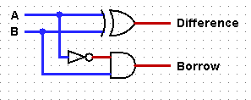

**Fig: Half-Subtractor Truth Table**

**Full- Subtractor:** The main difference between the **Full Subtractor** and the previous **Half Subtractor** circuit is that a full subtractor has three inputs. The two single bit data inputs  A (minuend) and B (subtrahend) the same as before plus an additional Borrow-in (B-in) input to receive the borrow generated by the subtraction process from a previous stage as shown below.

**A**

**Full - Subtractor**

**Difference**

**Bout**

**B**

**Bin**

**Block diagram of full–subtractor**Then the combinational circuit of a “full subtractor” performs the operation of subtraction on three binary bits producing outputs for the difference D and borrows B-out. Just like the binary adder circuit, the full subtractor can also be thought of as two half subtractors connected together; with the first half subtractor passing it’s borrow to the second half subtractor as follows.

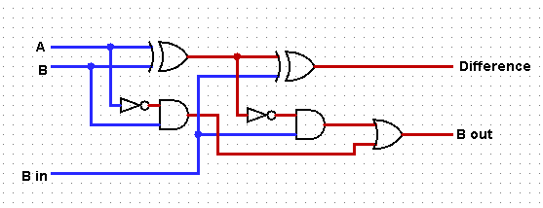

**Fig: Full-Subtractor**

|  |  |  |  |  |
| --- | --- | --- | --- | --- |
| **A** | **B** | **Bin** | **D** | **Bout** |
| **0** | **0** | **0** | **0** | **0** |
| **0** | **0** | **1** | **1** | **1** |
| **0** | **1** | **0** | **1** | **1** |
| **0** | **1** | **1** | **0** | **1** |
| **1** | **0** | **0** | **1** | **0** |
| **1** | **0** | **1** | **0** | **0** |
| **1** | **1** | **0** | **0** | **0** |
| **1** | **1** | **1** | **1** | **1** |

**Truth Table**

* **Circuit Diagram:  
  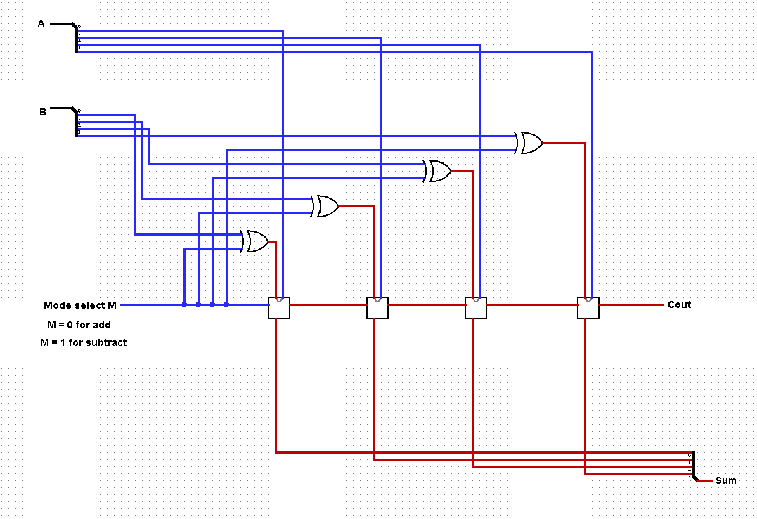**

**Fig D.1.1: 4-bit adder-subtractor**

* **Truth Table:**

|  |  |  |  |  |  |
| --- | --- | --- | --- | --- | --- |
| **Operation** | **M** | **A** | **B** | **C4** | **S4 S3 S2 S1** |
| **7+5** | **0** | **0111** | **0101** | **0** | **1100** |
| **4+6** | **0** | **0100** | **0110** | **0** | **1010** |
| **9+11** | **0** | **1001** | **1011** | **1** | **0100** |
| **15+15** | **0** | **1111** | **1111** | **1** | **1110** |
| **7-5** | **1** | **0111** | **0101** | **1** | **0010** |
| **4-6** | **1** | **0100** | **0110** | **0** | **1110** |
| **11-2** | **1** | **1011** | **0010** | **0** | **1001** |
| **15-15** | **1** | **1111** | **1111** | **0** | **0000** |

**Table F.1.1**

* **Question and Answer:**

**1.**

**2.**

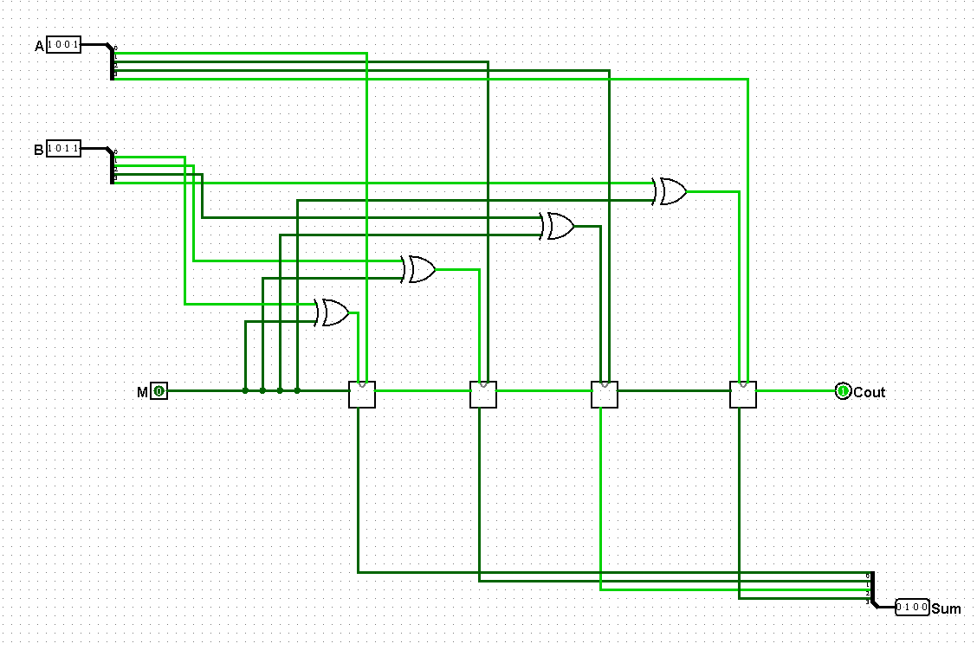

* **Discussion:**

This lab is about binary Adder-Subtractor. In this lab we learn about the concept of binary addition and subtraction. Also learn about what is half and full binary adders & subtractors. We also perform binary addition and subtraction using IC74283 and understand the concept of BCD addition and implement a BCD adder using IC74283 in this lab. During this lab we face some problems. Our practical data doesn’t match with our theory data. After doing forth time our practical data match with our theory data. In our lab there are problems in our equipments gates. Authority should solve this problem.